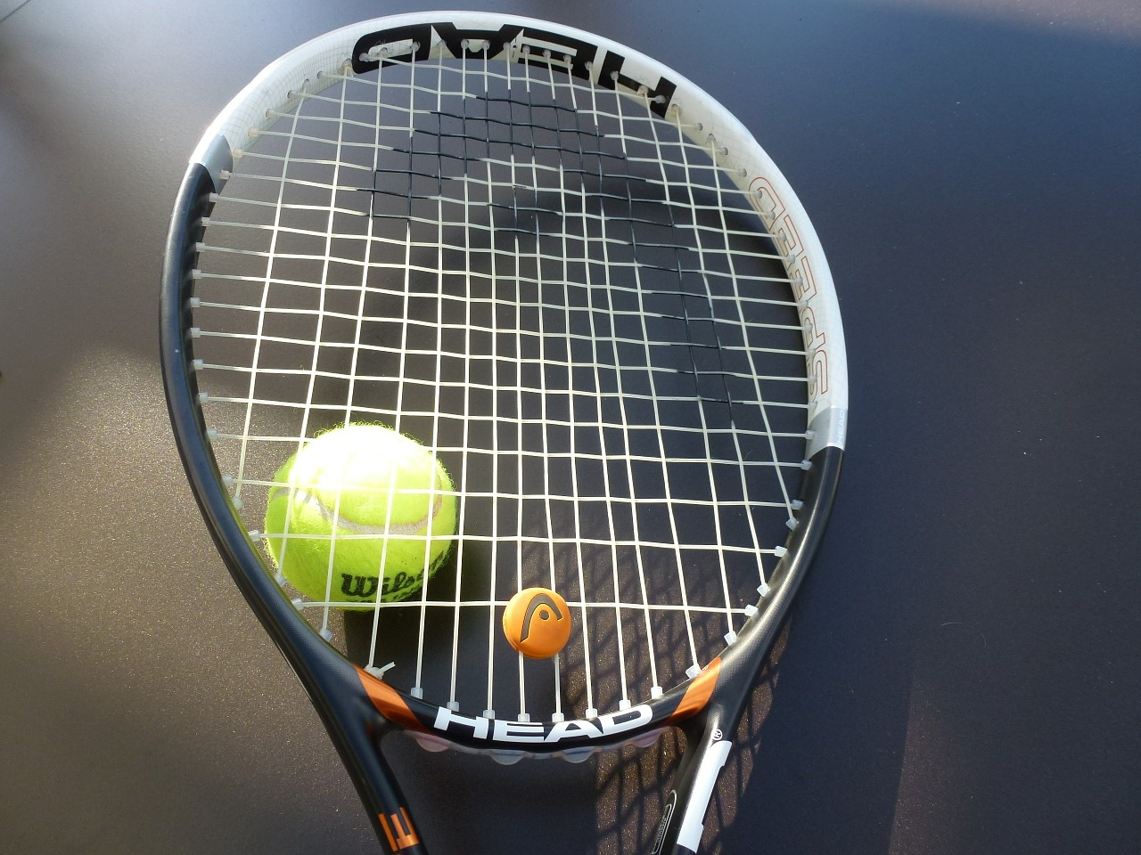 Oakley Lawn Tennis Club 
www.oakleytennisclub.org.uk
Application for Membership (2024/ 2025)

I wish to apply for membership of Oakley Lawn Tennis Club and enclose payment / paying by bank transfer (delete as applicable) for the appropriate category.

NAME:____________________________________________________
ADDRESS:___________________________________________________
_______________________________ POST CODE______________
Phone: Home:___________________ Mobile:___________________

E-mail address: _______________________________________________

Data Protection permission – please tick boxes as applicable

To comply with current Data protection and GDPR members are asked to agree to their records being held on a
computer database that is password protected.
As per the policy on the website I agree to my records being held securely 
I agree to having my phone no. and email on a list visible to other members 
I agree to photos being taken to publicise the club (including in Link magazine) 
I am interested in joining a club Whatsapp group 

Membership Category (Please tick as appropriate)
Adults (over 18yrs) £99.00 
Junior (18yrs and under) £20.00 
Senior (65yrs and over) £65.00 

Date of Birth (if 18 and under) ___________________________________
Membership is for one year from 1st April – 31st March, fees are due by 1st April.

Preferred method of payment is by bank transfer to OAKLEY LAWN TENNIS CLUB Lloyds Bank, Sort code: 30-90-53 Account number: 00190457. Please enter your name in the payment reference field. Please notify the Membership Secretary when payment has been made.
Payment can also be made by cheque or cash, cheques payable to “OAKLEY LAWN TENNIS CLUB”.

I have a key for the clubhouse 
I would like a key for the clubhouse £5.00 nominal charge 
I don’t need a key for the clubhouse 

Please return the completed form (and cheque / cash if applicable) to the Membership Secretary either by email or to the following address;
Fran Martin
42A Kennet Way
Oakley
Basingstoke
RG23 7AA
Tel: 01256-781328 email: franmartin@aol.com

